**Access GCP Instance using putty on Local Machine.**

Step1: Setup putty access Environment

1. Download and run puttygen and generate the public/private key

Use below link to download the puttygen and putty:

<https://www.chiark.greenend.org.uk/~sgtatham/putty/latest.html>

1. Download the puttygen(generate keys ) , putty to open the instance save puttygen and putty and double click to open

puttygen.exe (a RSA and DSA key generation utility)

32-bit: [puttygen.exe](https://the.earth.li/~sgtatham/putty/latest/w32/puttygen.exe) [(or by FTP)](ftp://ftp.chiark.greenend.org.uk/users/sgtatham/putty-latest/w32/puttygen.exe) [(signature)](https://the.earth.li/~sgtatham/putty/latest/w32/puttygen.exe.gpg)

64-bit: [puttygen.exe](https://the.earth.li/~sgtatham/putty/latest/w64/puttygen.exe) [(or by FTP)](ftp://ftp.chiark.greenend.org.uk/users/sgtatham/putty-latest/w64/puttygen.exe) [(signature)](https://the.earth.li/~sgtatham/putty/latest/w64/puttygen.exe.gpg)

putty.exe (the SSH and Telnet client itself)

32-bit: [putty.exe](https://the.earth.li/~sgtatham/putty/latest/w32/putty.exe) [(or by FTP)](ftp://ftp.chiark.greenend.org.uk/users/sgtatham/putty-latest/w32/putty.exe) [(signature)](https://the.earth.li/~sgtatham/putty/latest/w32/putty.exe.gpg)

64-bit: [putty.exe](https://the.earth.li/~sgtatham/putty/latest/w64/putty.exe) [(or by FTP)](ftp://ftp.chiark.greenend.org.uk/users/sgtatham/putty-latest/w64/putty.exe) [(signature)](https://the.earth.li/~sgtatham/putty/latest/w64/putty.exe.gpg)

Step 2: Generate Public and private keys using puttygen

[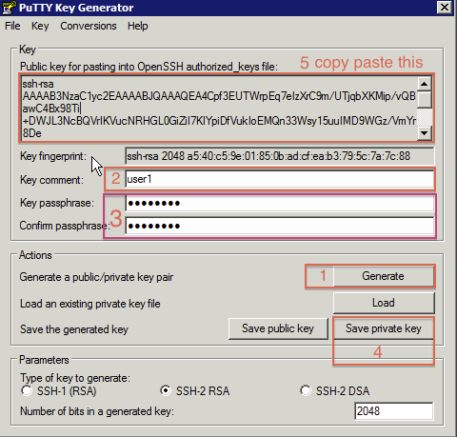](https://camo.githubusercontent.com/b69b8c428ff5f38a160973ef5d772b71d618eaf3/687474703a2f2f73746f726167652e676f6f676c65617069732e636f6d2f6763652d736372697074732f696d672f67656e65726174652d7468652d6b65792e706e67)

1. Click 'Generate' move the mouse around blank area till key completely get generated and displayed in the window
2. enter your username ( ubuntu) for ubuntu machine
3. enter your password, (key passphrase is optional )
4. save the private key with .ppk extension as below

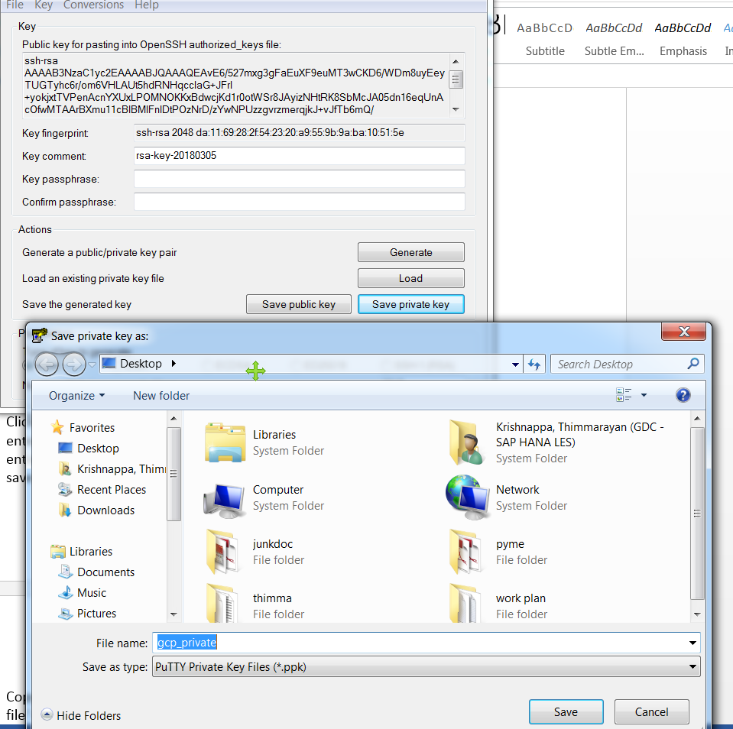

1. Copy the entire content of the 'Public key for pasting into OpenSSH authorized_keys file' window. Make sure, you copy every single character from the beginning to the very end

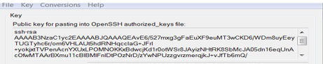

1. go to the cloud console <http://cloud.google.com/console> select your project and under Compute Engine / VM instances click on ssh Keys or click on the advanced options link paste in the contents copied at step 5 into the entry box indicated

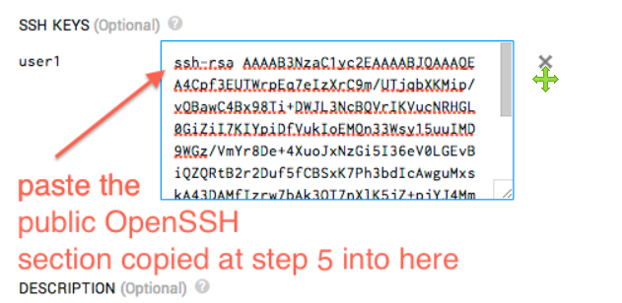

Step 3: setup putty in local machine for GCP instance access

1. Open putty, from the left hand menu go to Connection / SSH / Auth
2. On the Private key file for authentication browse and private key file location which was saved at step 4 ( private key with .ppk extension)

[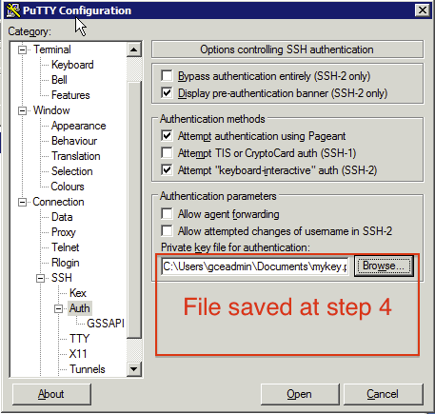](https://camo.githubusercontent.com/74a43095e25a5d1a661b770beef063ec67f1e88a/687474703a2f2f73746f726167652e676f6f676c65617069732e636f6d2f6763652d736372697074732f696d672f646566696e652d6b65792e706e67)

1. Enter the public IP address of the gcp instance and click open.

[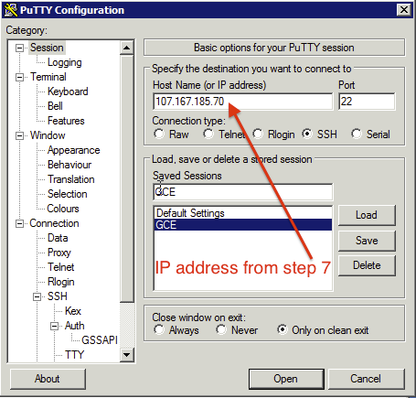](https://camo.githubusercontent.com/337e16e2f41db6d0f3aa7717eeb7fa180a0ed75c/687474703a2f2f73746f726167652e676f6f676c65617069732e636f6d2f6763652d736372697074732f696d672f736176652d73657474696e67732d6164642d69702e706e67)

1. Click Yes to accept the security alert

[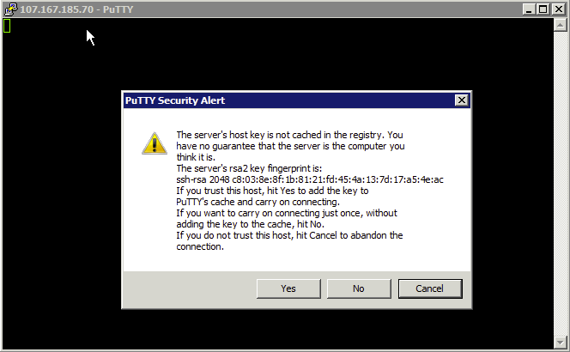](https://camo.githubusercontent.com/69622c52e615393e7c4cb0954d822d680d8100aa/687474703a2f2f73746f726167652e676f6f676c65617069732e636f6d2f6763652d736372697074732f696d672f6163636570742d6964656e746974792e706e67)

1. Login with the password to open the gcp instance in putty.

[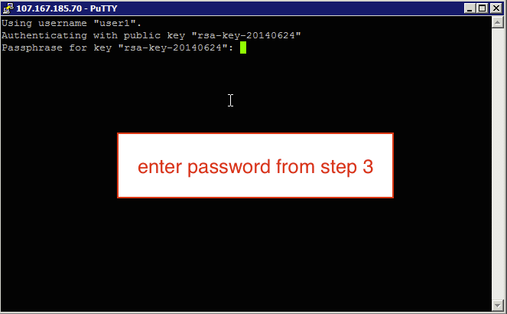](https://camo.githubusercontent.com/a268a8ae8bc3898c1521f6810564d1dddf1d5735/687474703a2f2f73746f726167652e676f6f676c65617069732e636f6d2f6763652d736372697074732f696d672f6c6f67696e2e706e67)

Reference document:

1. <https://gist.github.com/feczo/7282a6e00181fde4281b>